劉瑛

Liu Ying

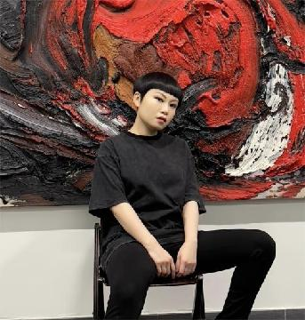

劉瑛，1982年生於中國山東，2006年畢業於中國美術學院，現生活和工作於香港。

2020年於香港藝術中心舉辦首次個展「劉瑛：有物混成」。2021年受亞洲藝術家聯盟邀請，參展在日本福岡九州藝文館舉辦的「第二十九屆亞洲國際美術展覽會」。2023年參加「第十五屆阿布扎比藝術展」。2024年受邀參加獅語畫廊駐地項目，並於上海獅語畫廊舉辦個展「玄冥有光」。同年10月受邀參加伊通公園藝術空間在首屆「台北藝術週」舉辦的群展，並在11月參加「第十六屆阿布扎比藝術展」。2025年10月受邀參加在香港教育大學舉辦的「台北香港視藝交流展覽」，11月參加「第十七屆阿布扎比藝術展」。2026年3月於香港獅語畫廊舉辦個展「劉瑛：道成肉身」及參加香港藝術中心舉辦的「珍藏香港藝術博覽」。其作品獲國際重要私人及機構收藏。

Liu Ying (b. 1982, Shandong, China) graduated from the China Academy of Art in 2006 and currently lives and works in Hong Kong.

Her debut solo exhibition, “LIU YING: THE CRUCIBLE OF FORMLESSNESS,” was presented at the Hong Kong Arts Centre in 2020. Invited by the Federation of Asian Artists in 2021, she was featured in the “29th Asian International Art Exhibition” at the Kyushu Geibun-kan in Fukuoka, Japan. In 2023, she participated in the 15th Abu Dhabi Art at Manarat Al Saadiyat. In 2024, she was invited to take part in the “Leo Gallery Artist Residency Project,” and her solo exhibition “Light Radiates in Darkness” at Leo Gallery (Shanghai). She was also featured in a group exhibition at the ITPARK Art Space during the inaugural Taipei Art Week in October and at the 16th Abu Dhabi Art at Manarat Al Saadiyat in November. In 2025, her work was included in “6x6 Visual Flow: Taipei and Hong Kong” at the EdUHK in October, as well as the 17th Abu Dhabi Art at Manarat Al Saadiyat in November. In March 2026, her solo exhibition “Visions of the Incarnate” is presented at Leo Gallery (Hong Kong), and she will also be featured in “COLLECT HK” at the Hong Kong Arts Centre.

