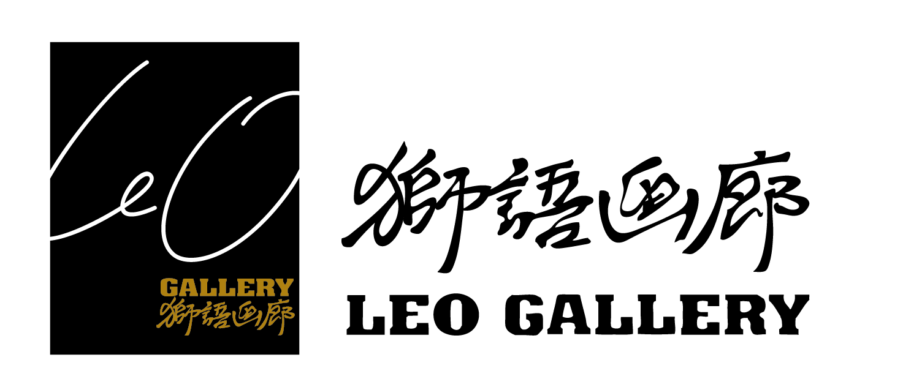
Li Lei

1965 Born in Shanghai, China
Currently lives and works in Shanghai, China

1983 | Graduated from Huashan Professional Art School, Shanghai, China
Present  Present | Executive Director of China Art Museum, Shanghai  Guest Professor at Tongji University, Shanghai

SOLO EXHIBITIONS

2015 | “Water to Water” Li Lei Art Exhibition, Hong Kong Art Centre, Hong Kong, China
2014 | "Shanghai Flower” Abstract Art by Li Lei, MoCA Shanghai, Shanghai, China
2013 | "Mind and Comprehension" Exhibition of Li Lei Abstract Paintings, Shanghai Longmen Art Projects, Shanghai, China
2010 | “抽象旋律”Li Lei Works Exhibition, Leo Gallery, Shanghai, China
2009 | Li Lei Works Exhibition, Alp Galleries, Franfurt, Germany
2003 | Li Lei Works Exhibition, Alp Galleries, New York, U.S.A.

GROUP EXHIBITIONS

2015 | La Biennale di Venezia, Venice, Italy
2014 | Xinjiang Art Biennale, Urumqi, China
2013 | “韵律与方法——中德当代绘画艺术交流展”  Hubei Art Museum, Wuhan, China
2012 | “无形之形——中国当代艺术展” 卡尔舒特艺术中心 Germany

COLLECTIONS

National Art Museum of China
China Art Museum, -Shanghai
Today Art Museum
Hubei Art Museum
Shandong Art Museum
Shenzhen Art Museum
Sichuan Art Museum
Guyuan Art Museum of Zhuhai
Minsheng Art Museum
Museum of Contemporary Art, Shanghai
Z-art Center, Shanghai
Xuhui Art Museum, Shanghai

李磊

1965年出生于上海市

現生活工作於中國上海

1983 | 畢業於上海市華山美術職業學校
現今  現今 | 任上海中華藝術宮執行館長  任上海同濟大學客座教授

個展

2015 | 《上善若水》——李磊藝術展 香港藝術中心 香港 中國
2014 | 《海上花》——李磊抽象藝術展 上海當代藝術館 上海 中國
2013 | 《心與識》——李磊抽象藝術展 龍門雅集 上海 中國
2010 | 《抽象旋律》——李磊個人作品展 獅語畫廊 上海 中國
2009 | 《李磊作品展》阿爾普畫廊Alp Galleries 法蘭克福 德國
2013 | 《李磊作品展》阿爾普畫廊Alp Galleries 紐約 美國

群展

2015 | 威尼斯雙年展聖馬力諾國家館 威尼斯 意大利
2014 | 新疆美術雙年展 烏魯木齊 中國
2013 | 《韻律與方法》――中德當代繪畫藝術交流展 湖北美術館 武漢 中國
2012 | 《無形之形》——中國當代藝術展 卡爾舒特藝術中心 德國

收藏

中國美術館
中華藝術宮
北京今日美術館
湖北美術館
山東美術館
深圳美術館
四川美術館
珠海古元美術館
民生現代美術館
上海當代藝術館
上海張江當代藝術館
上海徐匯藝術館

李磊

1965年出生于上海市
现生活工作于中国上海

1983 | 毕业于上海市华山美术职业学校
现今  现今 | 任上海中华艺术宫执行馆长  任上海同济大学客座教授

个展

2015 | 《上善若水》——李磊艺术展 香港艺术中心 香港 中国
2014 | 《海上花》——李磊抽象艺术展 上海当代艺术馆 上海 中国
2013 | 《心与识》——李磊抽象艺术展 龙门雅集 上海 中国
2010 | 《抽象旋律》——李磊个人作品展 狮语画廊 上海 中国
2009 | 《李磊作品展》阿尔普画廊Alp Galleries 法兰克福 德国
2013 | 《李磊作品展》阿尔普画廊Alp Galleries 纽约 美国

群展

2015 | 威尼斯双年展圣马力诺国家馆 威尼斯 意大利
2014 | 新疆美术双年展 乌鲁木齐 中国
2013 | 《韵律与方法》――中德当代绘画艺术交流展 湖北美术馆 武汉 中国
2012 | 《无形之形》——中国当代艺术展 卡尔舒特艺术中心 德国

收藏

中国美术馆
中华艺术宫
北京今日美术馆
湖北美术馆
山东美术馆
深圳美术馆
四川美术馆
珠海古元美术馆
民生现代美术馆
上海当代艺术馆
上海张江当代艺术馆
上海徐汇艺术馆

